INSTRUCTIONS FOR THE PREPARATION OF PAPERS
for the WCPEC-8

Author(s)
Company / Institute(s)
Address(es)

ABSTRACT: These notes include important information on how to prepare and submit your paper. Read the notes carefully and follow them precisely. Your paper must be written in English. The layout of your paper should be exactly the same as this master document. In order to prepare your layout, save this document with a new name (use your session code as the name for the document, e.g. 4AV.1.20) and use it as a template. Substitute the following text with the text of your paper without changing the layout (see section 3). Do not change font type and size, line spacing, page margins and the structure of this document. Do not insert page numbers and page headers/footers. Ignoring these instructions might cause problems and delays in the publication of the Conference Proceedings. In case your abstract was selected for participation in the peer review process for publication in a Scientific Journal (PiP, Solar RRL or EPJ Photovoltaics), as well as your submission to the journal, you can also publish your Short Paper in the conference proceedings (N.B. it is essential that the contents of both papers differ by at least 50%). Published papers will include a note to indicate that the Full Paper was submitted to the selected Journal. The Conference Proceedings will be online searchable, online citable and available for full permanent free access and download on the EU PVSEC Proceedings website (www.eupvsec-proceedings.com). If you have any questions, please do not hesitate to contact us (see section 6.3).
Keywords: see the list of keywords

1 DEADLINES AND DELIVERY

Your original paper has to be submitted online between 19th - 29th September 2022 through the corresponding author´s user area (www.wcpec-8.com/index.php/userarea). Kindly note that only Corresponding Authors of each submission may upload final manuscripts. It means that the corresponding author is the only author from each paper that is able to complete the submission (as is the case for abstract submission). If the manuscript is not available during this period, your paper cannot be published in the Conference Proceedings.
The document must be submitted in both Microsoft Word and Adobe Acrobat PDF formats. You may rest assured that we do not make any changes in your manuscripts. The necessity of providing us with a copy in Word format is to allow us the option to convert the Word document into PDF if we encounter difficulties opening your PDF version.
To upload the paper, follow the step-by-step procedures provided in the user area.
In addition to the manuscript, complete the mandatory electronic Copyright Transfer Agreement as one of the steps of the online submission.
Please make sure that the paper you submit is the final version.
Your paper can only be published if it was presented during the conference and at least one of the authors (presenter) is duly registered. The Conference Registration Area is available on the website Registration (wcpec-8.com).

2 PREPARING THE MANUSCRIPT

2.1 Volume of paper
The complete paper should not exceed 1 MB including illustrations. This is a very good proven capacity for final papers. Note that there is no limit in the number of pages. An adequate number is 3 to 6 pages.

2.2 Organisation of the paper
The title of the paper should be informative and concise. It should be followed by the author(s) name(s) - listing the principal author first-, organisation, address, telephone, fax and email address.
Precede the body of your paper with an abstract of 100 to 200 words, giving a brief account of the most relevant aspects of your paper. Please avoid using symbols, graphics and formulas in this part of the document as this section will appear as plain text on the WCPEC-8 Proceedings website.
Next, in order of importance, select the three to five most relevant keywords from the enclosed list of keywords and include them in your paper, separating them with commas. You may use additional keywords in case a keyword you would like to use does not appear on the list.
The body of the text must be in two columns. Number each heading using decimal numbering. Follow the layout specifications in section 3 below.

3 LAYOUT SPECIFICATIONS

The layout of your paper should have exactly the same format as these notes.
Select the printer option “Acrobat Distiller” or Adobe PDF (version 8.0 and up) before starting to work on this document in order to avoid accidental displacement of layout elements afterwards when converting the Word file into PDF format. Please abstain from freeware products which are not 100% compatible with Adobe PDF. Should you not have the above technical requirements, please contact us (see 6.3).

3.1 Fonts and type size
Font type: Times New Roman. Font size: 9pt. Line spacing: single. Text alignment: justified left and right. Captions should be the same font and size as the typeface used for the text. Make sure that illustrations are clear and easy to read. Please do not use any other font than Times New Roman.

3.2 Page size
Page size must be A4 (210mm x 297mm).
Margins: top: 32mm; bottom: 19mm; left: 25mm; right: 25mm. Text or images can't be outside these margins. The body of the text must be in two equal columns. The width of the columns should be 73,6mm.

3.3 Layout of the text
Begin at the top of the first page with the title of the paper, in capital letters, bold and centered. Leave two blank lines between the title and the name of the author(s), and list the surname preceded by the first name. On the following lines, give the name of the company or institute, wherever applicable, and the full address. When several authors prepare a paper, the name of the principal author should appear first and the name of every institute should be easy to depict. Next, leave two blank lines and then type an abstract of no more than 200 words (indent the whole block as at the top of this document). At the end of the abstract, give your list of keywords. Leave another two blank lines between the abstract and the body of the paper, which should be typed in two columns.

3.4 Headings
Leave two blank lines before each section and one blank line before the heading of each sub-section. Headings and sub-headings should be numbered (e.g. 3, 3.1, 3.2). There should be no blank line after the title of the sub-sections, only an indentation to indicate the beginning of a paragraph. Section headings should be in capital letters, sub-section headings in upper and lower case. Headings should be normal text – not underlined or in bold.

4 ADDITIONAL COMPONENTS

4.1 Illustrations
Illustrations (drawings, graphs, photographs, etc.) should not exceed 50% of the whole paper and should be placed near their citation. Accepted formats are: .jpg, .png and .gif. Please note that vector graphics need to be converted into bit-mapped graphics.
Illustrations should have a resolution of 300 dpi, using simple colours (Standard + RGB) and be placed at 100% scale (i.e. if an illustration covers the full column width, it should be of approx. 860 pixels). Illustrations should not be taken from previously-printed material.
Illustrations should have the layout in line with the text.
Figures must be numbered (e.g. Fig. 1) in the text and in the figure caption. Captions should be clear enough to allow comprehension of the illustration without reference to the text.
Graphs must not be imported from Excel, but be inserted as a picture (.jpg, .png or .gif). Please use simple contrasting colours (Standard + RGB) instead of fill patterns. See Fig. 1 for good/bad example.
Please make sure that the PDF file size of the final document does not exceed 1 MB. If your document size should be larger than this, verify the resolution and scale down the inserted images.

Good example with contrasting colours:

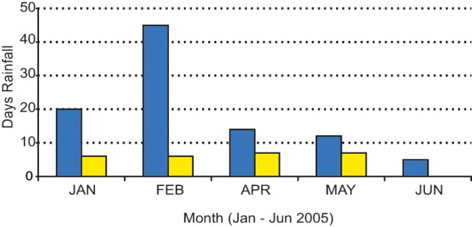

Bad example with fill patterns:

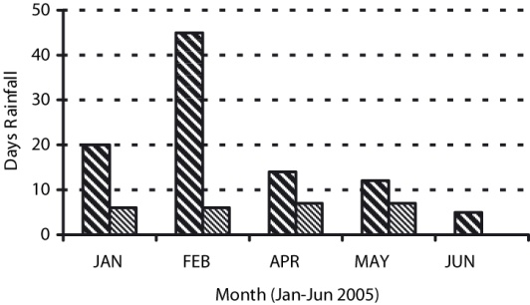Figure 1: Clear line drawings are essential

4.2 Tables
Tabular presentation of data is an easy way of condensing many items. Refer to tables by using Roman numerals. All tables must be numbered and captioned (see Table I).

Table I: Standing waves ratio

110MHz 120MHz 130MHz
Standing waves ratio 1.86 1.73 1.40
Reflection coefficient 0.32 0.28 0.16
Phase 3.78 3.89 4.02

4.3 References
References should not appear as footnotes but should be gathered together at the end of the text. When referring to them in the text, type the corresponding reference number in brackets [1]. References should be numbered:
[1] M. Smith, A. Miller, Proceedings 17th European Photovoltaic Solar Energy Conference, Vol. I (2002) 903.
[2] K.W. Boer, Solar Cells 16 (1996) 591.

5 SPECIAL REQUESTS FOR THE PDF VERSION

5.1 Printer
Select Adobe PDF (version 8.0 and up) as the printer option to convert your Word file into PDF version (1.6 or 1.7).
Go to printer properties and click on “Acrobat PDF settings”, then choose as conversion settings: “Press” quality.

5.2 Password / Security
Please do not use passwords nor security when making your PDF file. You may rest assured that we do not make any changes in your manuscript. As the header and page numbering will be added by us, we need to ensure that your PDF file is not password protected.

6 OTHER POINTS

6.1 Permissions
Authors are fully responsible for their papers. They must take the necessary steps to obtain permission for using any material that might be protected by copyright.

6.2 Copyright
Please be aware that on submission of your manuscript, you transfer the copyright to WIP, publisher of the proceedings.

6.3 Further information
Papers must be submitted online between 19th to 29th September to the user area of corresponding authors of each paper at www.wcpec-8.com/index.php/userarea. All requests regarding the preparation of the paper should be addressed to:

WIP
attn. WCPEC-8 Programme Secretariat
Tel. +49-89-720 12 -735, Fax +49-89-720 12 791
E-mail: pv.manuscripts@wip-munich.de

7 SUMMARY OF THESE NOTES

• Use this layout as a guide to write your paper. Write your paper directly on this document and save it with the name of the session code.
• Select Adobe PDF (version 8.0 and up) before starting to work on this document.
• Write your paper in English, A4 format, Font Times New Roman, 9 pt.
• Use contrasted pictures/illustrations placed at 100% (do not resize them in Microsoft Word), 300 dpi with Standard + RGB colors in .jpg, .png or .gif format.
• The size of the final document in PDF cannot be larger than 1 MB.
• Submit your paper online between 19th to 29th September to the user area of corresponding authors of each paper at www.wcpec-8.com/index.php/userarea, both in Microsoft Word and Adobe Acrobat PDF format.
• Complete the mandatory electronic Copyright Transfer Agreement as one of the steps of the online submission.

8 AUTHOR´S CHECKLIST FOR DELIVERY OF THE FINAL MANUSCRIPT

Before submitting your manuscript at the Conference please make sure that:

- Your paper follows the layout specified in these guidelines
- Your paper does NOT contain header or page numbering
- The digital version of your manuscript is uploaded in the user area in Microsoft Word AND in Adobe Acrobat PDF format
- The digital files are named with the name of the session reference code
- Your PDF is NOT password protected

If you need any further assistance, please contact us.

Thank you very much for your kind attention.

The Publisher

